**PYTHON PROJECT**

**WEBSCRAPPING**

**1. PROJECT TITLE:-**

Web scrapping of Flipkart E-Commerce Website Using BeautifulSoup Module in Python Using in PyCharm Platform.

**2. PROJECT DESCRIPTION:-**

In This Project Collects the Some Useful Data From Flipkart E-Commerce Website Link by Using of the Written Python Programming Code in PyCharm by Me. That Flipkart E-Commerce Website is Scrapping to Collect the Data of realme Mobile Phone Product Related Name, Model, Specifications, and Contact Details...etc. details. This Web Scrapping is doing from the Flipkart E-Commerce Website Product Link.

**3. CODING:-**

**Process for New Project:-**

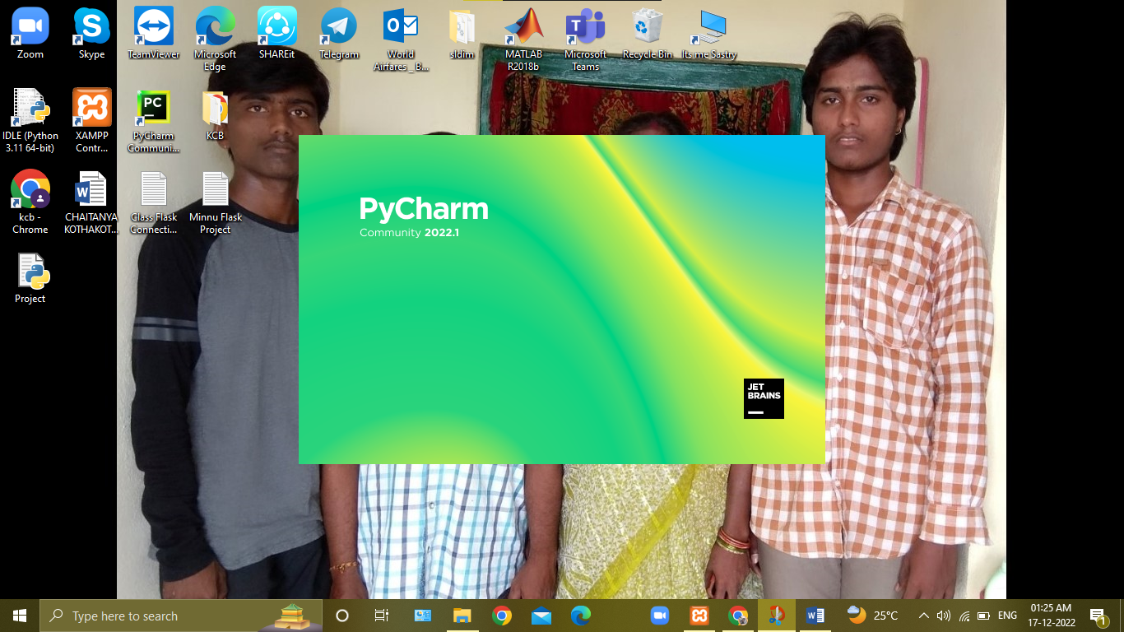

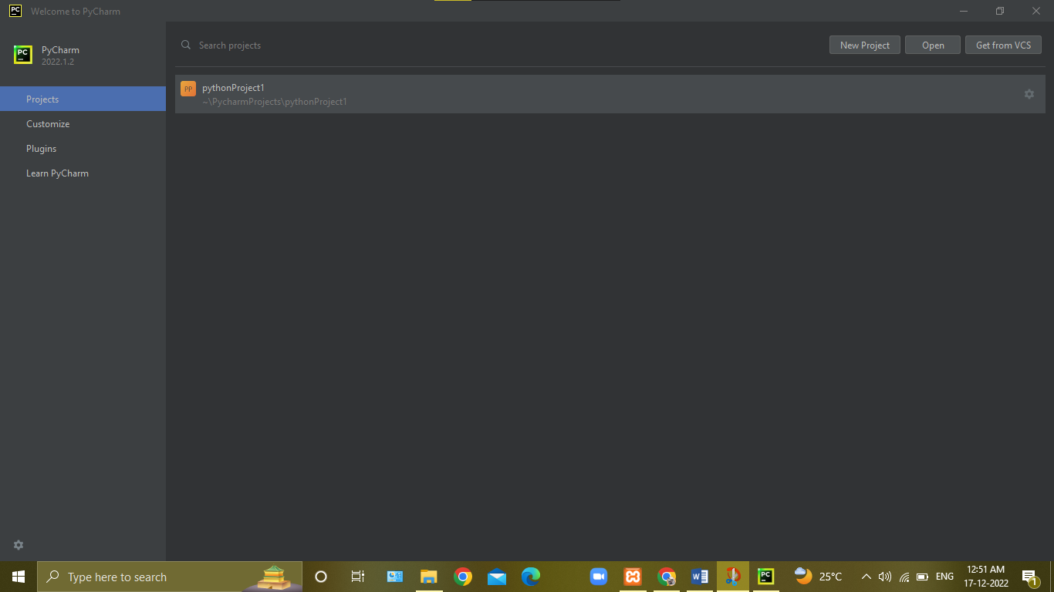

**Click To New Project**

**Enter New Project Name**

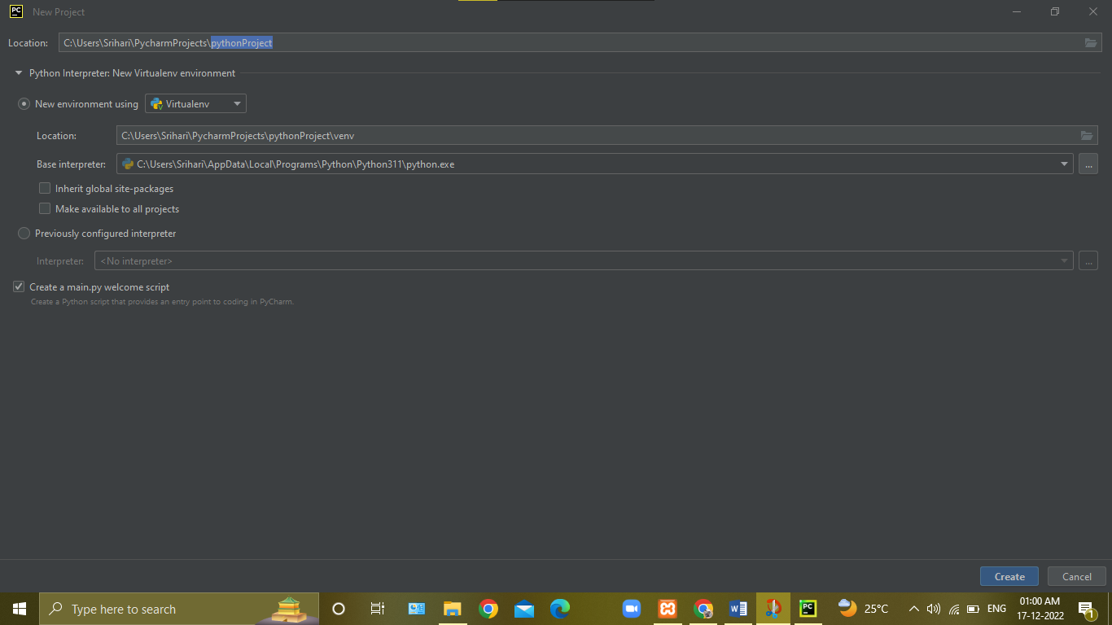

**Click To Create New Project**

**Click to Create Virtual Environment**

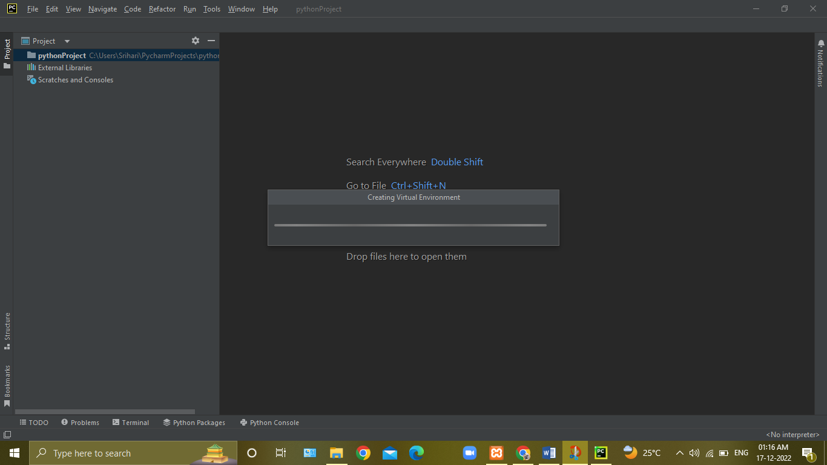

**Creating of Venv**

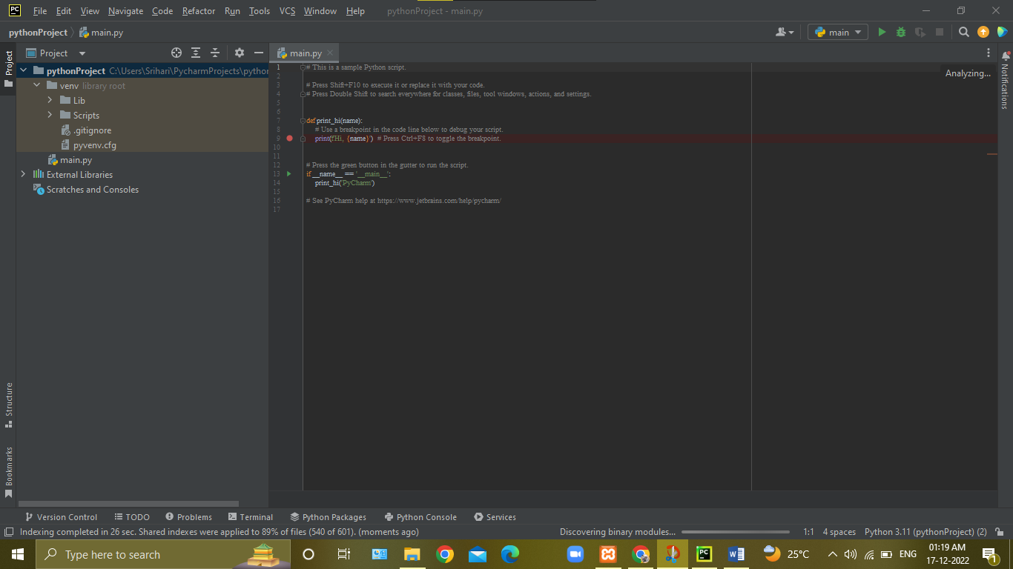

**Pycharm Work Area**

**Installation of Modules:-**

In PyCharm>>>Go to **Files** click**>>>** Go to **Settings** click>>> Go to **Project: pythonProject** click>>**>**select **Python Interpreter** click**>>>** click **‘+’** button>>**>** Search **requests, bs4>>>**click **install>>>**click **ok.**

**Click to Files**

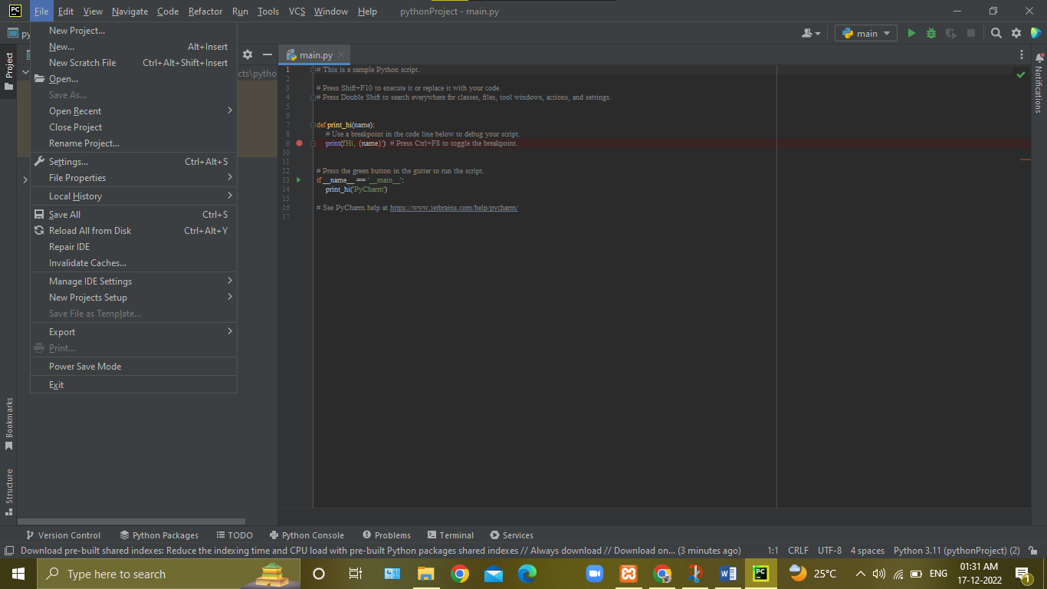

**Click to Settings**

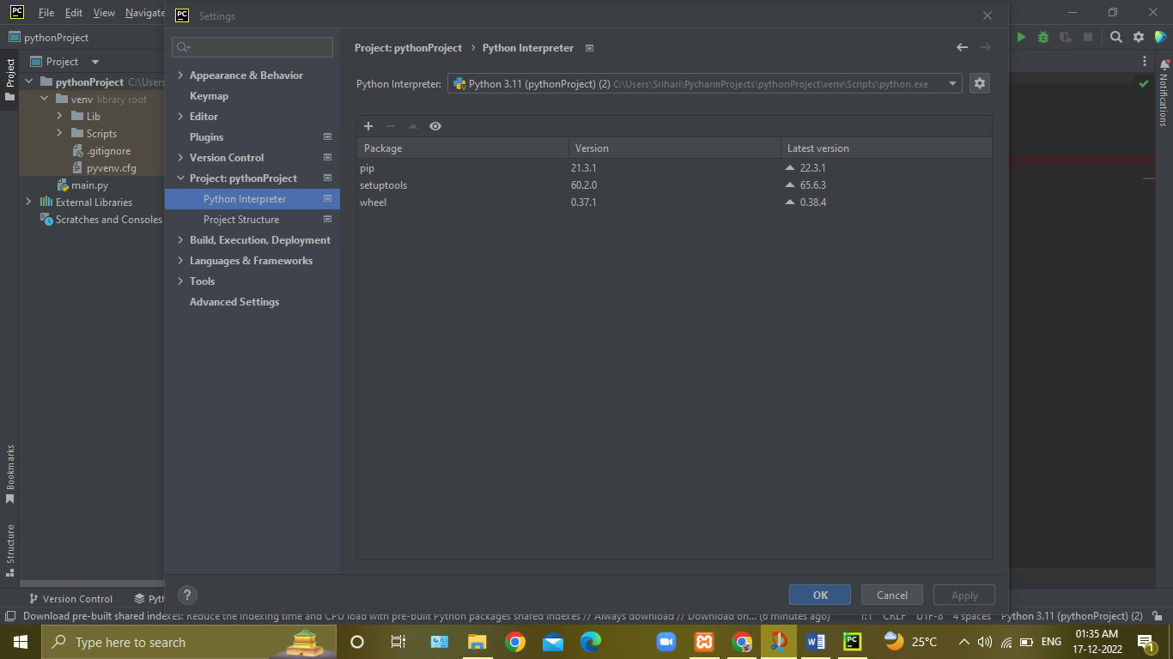

**Click to ‘+’ button**

**Search requests, bs4 Modules**

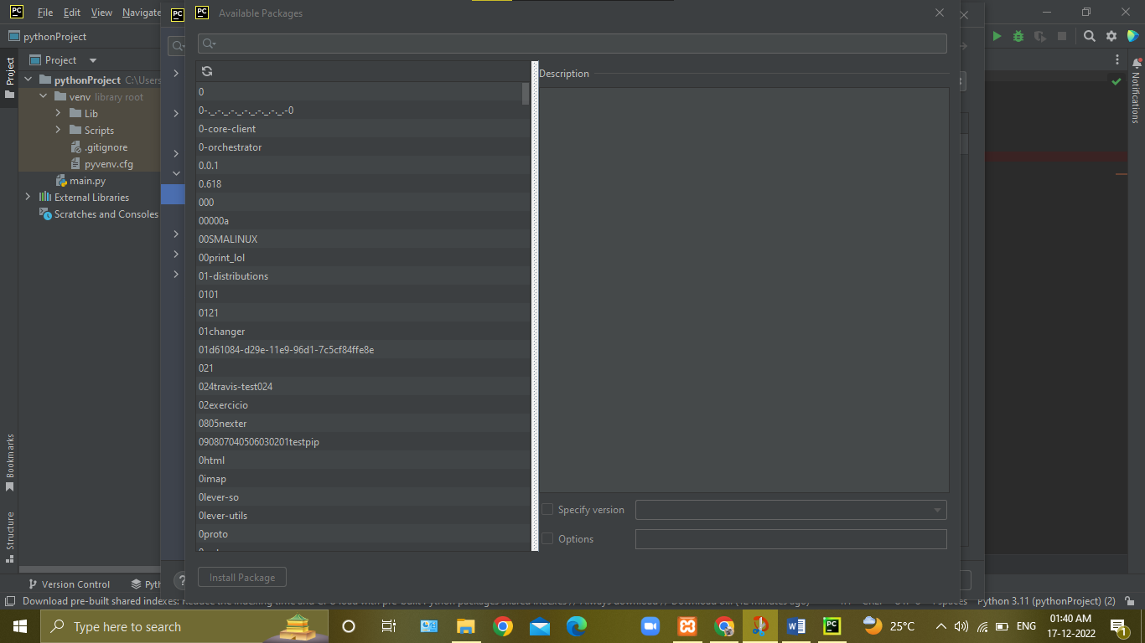

**Click to Install Package**

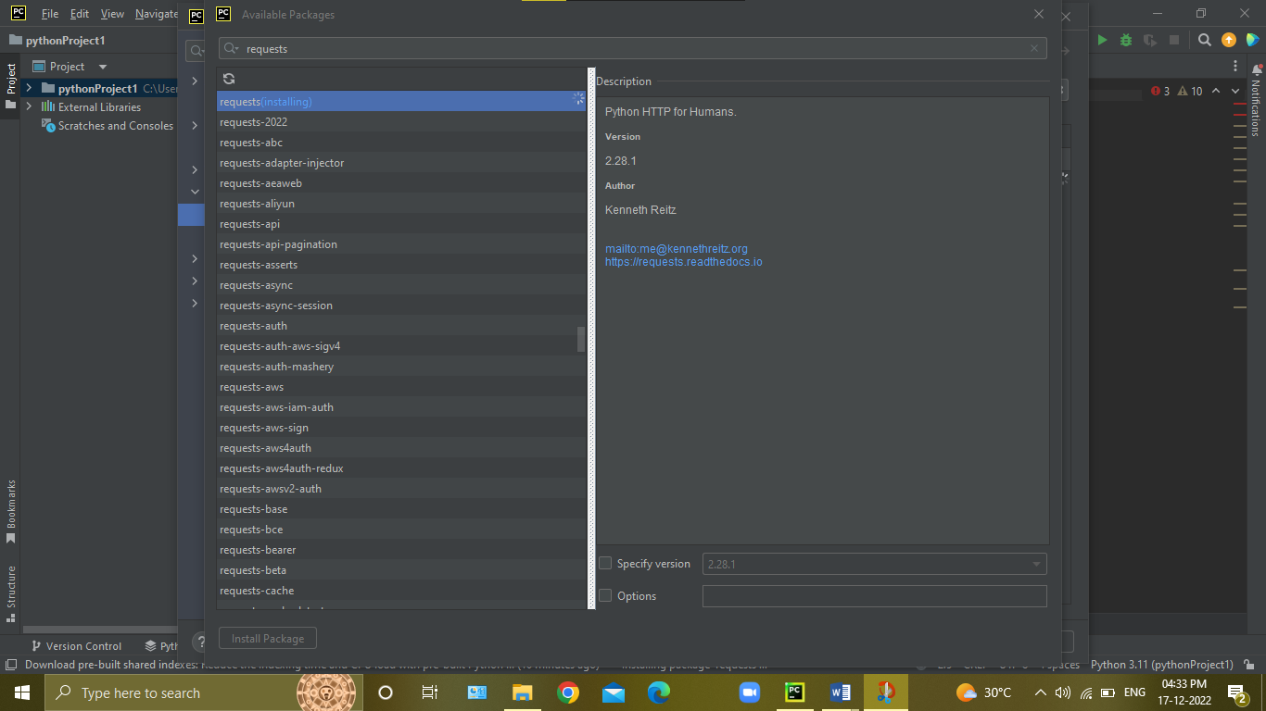

**Installing requests Module**

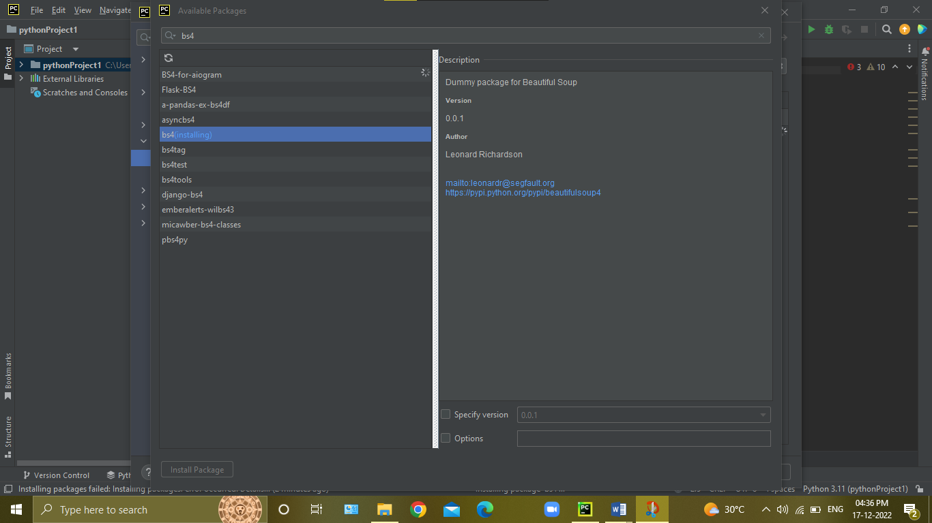

**Installing requests Module**

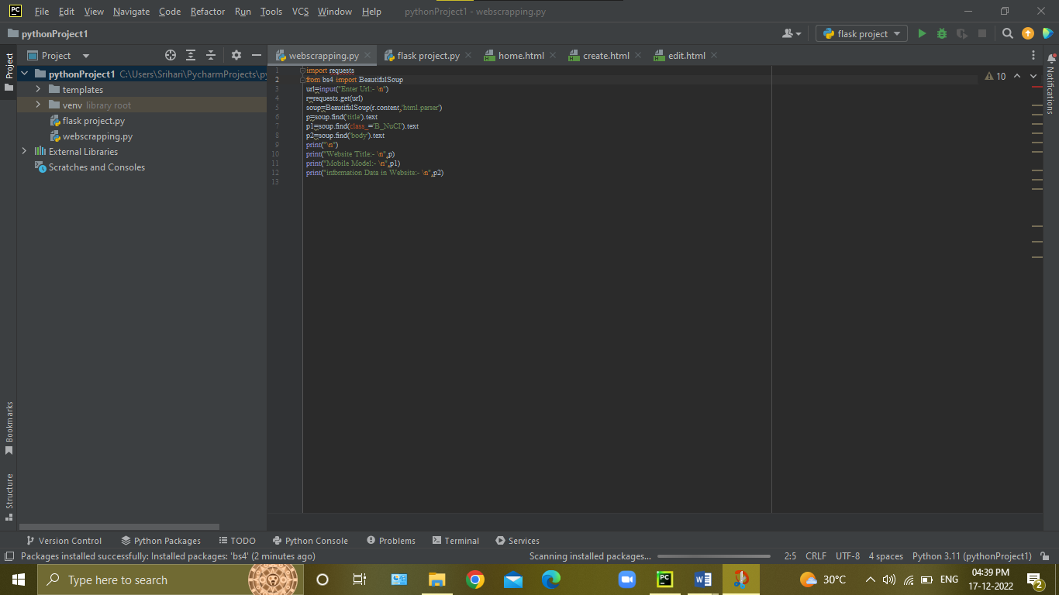

**Python Executing File**

**PROGRAM:-**

import requests

from bs4 import BeautifulSoup

url=input("Enter Url:- \n")

r=requests.get(url)

soup=BeautifulSoup(r.content,'html.parser')

p=soup.find('title').text

p1=soup.find(class_='B_NuCI').text

p2=soup.find('body').text

print("\n")

print("Website Title:- \n",p)

print("Mobile Model:- \n",p1)

print("information Data in Website:- \n",p2)

**4. INPUT:-**

**input:-**

<https://www.flipkart.com/realme-narzo-30-pro-5g-blade-silver-64-gb/p/itm8cb3552276c44?pid=MOBGYFAXUDBCN8MK&cmpid=product.share.pp&_refId=PP.2f4907d3-0dba-4dbc-ac2f-c9593c8f77bd.MOBGYFAXUDBCN8MK&_appId=WA>

**Input:-**

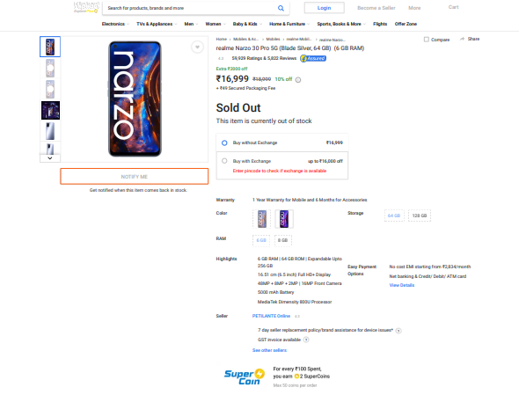

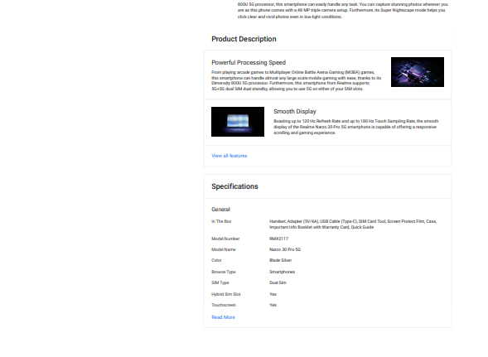

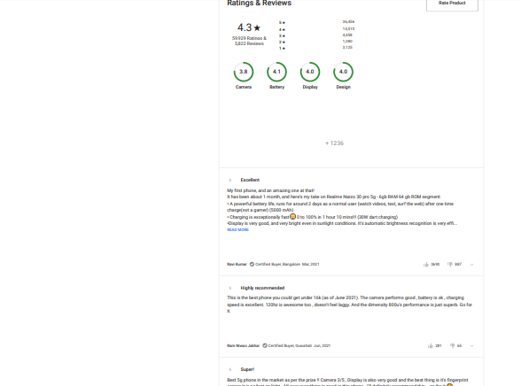

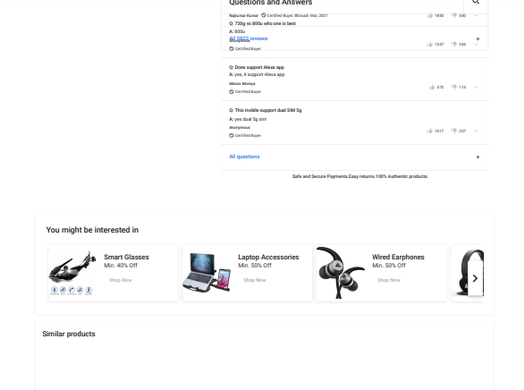

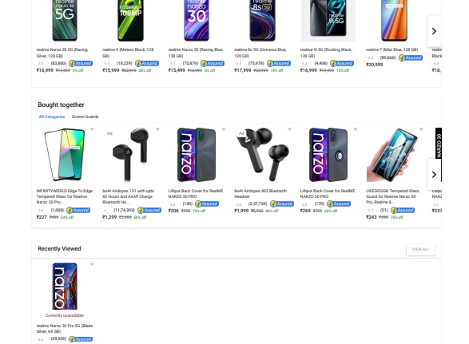

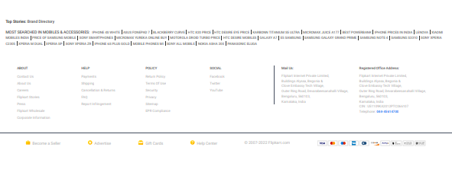

**5. OUTPUT:-**

**Output:-**

C:\Users\Srihari\PycharmProjects\pythonProject\venv\Scripts\python.exe C:\Users\Srihari\PycharmProjects\pythonProject\webscrapping.py

Enter Url:-

https://www.flipkart.com/realme-narzo-30-pro-5g-blade-silver-64-gb/p/itm8cb3552276c44?pid=MOBGYFAXUDBCN8MK&cmpid=product.share.pp&_refId=PP.2f4907d3-0dba-4dbc-ac2f-c9593c8f77bd.MOBGYFAXUDBCN8MK&_appId=WA

Website Title:-

realme Narzo 30 Pro 5G ( 64 GB Storage, 6 GB RAM ) Online at Best Price On Flipkart.com

Mobile Model:-

realme Narzo 30 Pro 5G (Blade Silver, 64 GB)  (6 GB RAM)

information Data in Website:-

Explore PlusLoginBecome a Seller More CartNOTIFY MEGet notified when this item comes back in stock.HomeMobiles & AccessoriesMobilesrealme Mobilesrealme Narzo 30 Pro 5G (Blade Silver, 64 GB) (6 GB RAM)

CompareSharerealme Narzo 30 Pro 5G (Blade Silver, 64 GB)  (6 GB RAM)4.359,929 Ratings & 5,822 ReviewsExtra ₹2000 off₹16,999₹18,99910% offi+ ₹49 Secured Packaging FeeSold OutThis item is currently out of stockBuy without Exchange₹16,999Buy with Exchangeup to ₹16,000 offEnter pincode to check if exchange is availableWarranty1 Year Warranty for Mobile and 6 Months for AccessoriesColorBlade SilverSword BlackPlease select a Color to proceed✕Storage64 GB64 GB128 GB128 GBPlease select a Storage to proceed✕RAM6 GB6 GB8 GB8 GBPlease select a RAM to proceed✕Highlights6 GB RAM | 64 GB ROM | Expandable Upto 256 GB16.51 cm (6.5 inch) Full HD+ Display48MP + 8MP + 2MP | 16MP Front Camera5000 mAh BatteryMediaTek Dimensity 800U ProcessorEasy Payment OptionsNo cost EMI starting from ₹2,834/monthNet banking & Credit/ Debit/ ATM cardView DetailsRead all detailsSellerPETILANTE Online4.37 day seller replacement policy/brand assistance for device issues*?GST invoice available?See other sellersDescriptionIf you love playing games and are looking for a smartphone that can help you enjoy a smooth and responsive gaming experience, then say hello to the Realme Narzo 30 Pro 5G smartphone. Boasting a powerful Dimensity 800U 5G processor, this smartphone can easily handle any task. You can capture stunning photos wherever you are as this phone comes with a 48 MP triple camera setup. Furthermore, its Super Nightscape mode helps you click clear and vivid photos even in low-light conditions. Read MoreProduct DescriptionPowerful Processing SpeedFrom playing arcade games to Multiplayer Online Battle Arena Gaming (MOBA) games, this smartphone can handle almost any large scale mobile gaming with ease, thanks to its Dimensity 800U 5G processor. Furthermore, this smartphone from Realme supports 5G+5G dual SIM dual standby, allowing you to use 5G on either of your SIM slots.

Smooth DisplayBoasting up to 120 Hz Refresh Rate and up to 180 Hz Touch Sampling Rate, the smooth display of the Realme Narzo 30 Pro 5G smartphone is capable of offering a responsive scrolling and gaming experience.

30 W Dart ChargeBoasting a highly efficient 30 W Dart Charge, this Realme smartphone ensures that it doesn’t overheat even when you’re playing games and charging the phone simultaneously.

5000 mAh BatteryDon’t let constant low-battery notifications force you to pause your game. This smartphone comes with a 5000 mAh battery that lets you play games for up to 12 hours before you need to recharge it.

Super Power Saving ModeThanks to Super Power Saving mode, this smartphone can easily last for up to 24 hours even when its charge is at 5%.

48 MP AI Triple Rear CameraCapture stunning photos and record clear videos on this Realme smartphone as it comes with a 48 MP primary camera on its rear. It also includes an 8 MP ultra-wide-angle lens and a 4 cm macro lens to help you capture images of landscapes as well as intricate details of subjects/objects.

Super Nightscape ModeBring life to the night scenes by capturing stunning photos in low-light environments via the Super Nightscape mode.

Night FiltersThis smartphone offers about three amazing night filters that help you enhance your nighttime clicks. So, whether you’re partying in a club or at a friend’s place celebrating their birthday at midnight, you can capture breathtaking moments using these filters.

16 MP In-display SelfieIf you love capturing selfies, then you must get your hands on this smartphone. Featuring a 16 MP selfie camera, this smartphone helps you click amazing photos that you can post on Social Media and garner likes. The various modes, such as AI Beauty, Super Nightscape, and Portrait, further enhance your selfie-capturing experience.

Classy DesignBoasting an incredible classic matte design, with an enhanced AG coating process and 3D curves, this smartphone is not only sure to grab the attention of onlookers but also comfortable to hold.

Dolby Atmos and Hi-res AudioImmerse yourself in the content, be it while grooving to the latest hits, watching videos, or playing games, as this smartphone delivers rich and high-fidelity audio as well as visual quality.

Secure LoginThe fingerprint sensor of this smartphone helps you safely unlock it in an instant so that you can take advantage of its amazing features and stay entertained.

View all featuresSpecificationsGeneralIn The BoxHandset, Adapter (5V/6A), USB Cable (Type-C), SIM Card Tool, Screen Protect Film, Case, Important Info Booklet with Warranty Card, Quick GuideModel NumberRMX2117Model NameNarzo 30 Pro 5GColorBlade SilverBrowse TypeSmartphonesSIM TypeDual SimHybrid Sim SlotYesTouchscreenYesOTG CompatibleYesSound EnhancementsHi-Res Audio Certification, Dolby Atmos Sound, MT6359 Audio Decoding ChipDisplay FeaturesDisplay Size16.51 cm (6.5 inch)Resolution2400 x 1080 PixelsResolution TypeFull HD+GPUARM G57 MC3Display TypeFull HD+ LCD In-cell DisplayDisplay Colors16.7MOther Display Features120 Hz Refresh Rate, 2.5D Gorilla Glass 3, 20:09 Display Ratio, 90.50% Screen-to-Body Ratio, 180 Hz Touch Sampling Rate, Screen Contrast: AVE 1500:1, 480nit (Typ) Max Brightness, Color Saturation: NTSC 81.5% (Typ), COG Sealing ProcessOs & Processor FeaturesOperating SystemAndroid 10Processor TypeMediaTek Dimensity 800UProcessor CoreOcta CorePrimary Clock Speed2.4 GHzSecondary Clock Speed2 GHzOperating Frequency2G GSM: 850/900/1800/1900, WCDMA: B1/B2/B4/B5/B6/B8/B19, 4G LTE TD: B34/B38/B39/B40/B41 (2515 - 2675MHz), 4G LTE FDD: B1/B2/B3/B4/B5/B7/B8, 5G NSA: N41(2515 - 2675MHz)/N77/N78/N79, 5G SA: N1/N41(2515-2675MHz)/N78/N79Memory & Storage FeaturesInternal Storage64 GBRAM6 GBExpandable Storage256 GBSupported Memory Card TypemicroSDMemory Card Slot TypeHybrid SlotCamera FeaturesPrimary Camera AvailableYesPrimary Camera48MP + 8MP + 2MPPrimary Camera FeaturesTriple Rear Camera Setup, 48MP Primary (Samsung S5KGM1st, f/1.8 Aperture, FOV 79.8 Degree, 25.37mm Focal Length, 6P Lens, 1/1.2 inch Sensor, Pixel Size: 0.80um, 4 in 1 output 1.4μm, PDAF) + 8MP Wide-angle (Hynix Hi846, f/2.3 Aperture, FOV 119 Degree, 15.72mm Focal Length, 5P Lens, 1/4 inch Sensor, Pixel Size: 1.12um, FF) + 2MP Macro (GC02K0, f/2.4 Aperture, FOV 88.8 Degree, 23.21mm Focal Length, 3P Lens, 1/5 inch Sensor, Pixel Size: 1.65um, FF), CMOS Sensor, Video Stabilization: EIS, UIS, and UIS Max, 20 Continuous Shooting, Photograph Function: 48MP Mode, Ultra Steady Video, Ultra Steady Max Video, Night Mode, Panoramic View, Expert, Timelapse, HDR, Ultra-wide, Ultra Macro, AI Scene Recognition, AI Beauty, Filter, Slow Motion, Bokeh Effect ControlOptical ZoomNoSecondary Camera AvailableYesSecondary Camera16MP Front CameraSecondary Camera Features16MP Front Camera (Samsung S5K3P9SP, f/2.1 Aperture, FOV 79.3 Degree, 1/3.1 inch CMOS Sensor, Pixel Size: 1.0μm, 5P Lens), FF, EIS, Photography Functions: Ultra Steady Video, Portrait Mode, Timelapse, Panoramic View, Beauty Mode, HDR, Face-Recognition, Filter, Night Mode, Bokeh Effect ControlFlashRear FlashHD RecordingYesVideo RecordingYesVideo Recording ResolutionRear Camera: 720p (at 30/60fps), 1080p (at 30/60fps), 4k (at 30fps), Slo-mo Video: 720P (at 240fps), 1080P (at 120fps), Front Camera: 720p (at 30fps), 1080p (at 30fps)Digital Zoom10XFrame Rate30 fps, 60 fpsDual Camera LensPrimary CameraCall FeaturesCall RecordsYesConnectivity FeaturesNetwork Type5G, 4G VOLTE, 4G, 3G, 2GSupported Networks5G, 4G VoLTE, 4G LTE, WCDMA, GSMInternet Connectivity5G, 4G, 3G, Wi-Fi, EDGE, GPRS3GYesGPRSYesPre-installed BrowserGoogle ChromeBluetooth SupportYesBluetooth Versionv5.1Wi-FiYesWi-Fi VersionIEEE 802.11 a/b/g/n/ac (2.4GHz | 5GHz)Wi-Fi HotspotYesNFCNoInfraredNoUSB ConnectivityYesEDGEYesAudio Jack3.5mmMap SupportGoogle MapsGPS SupportYesOther DetailsSmartphoneYesTouchscreen TypeCapacitiveSIM SizeNano + NanoUser InterfaceRealme UI v1.0 (Based on Android 10)SMSYesGraphics PPI405 PPISensorsMagnetic Induction Sensor, Light Sensor, Proximity Sensor, Gyro-meter, Acceleration SensorBrowserGoogle ChromeRingtones FormatOGGOther FeaturesDual Channel RAM and ROM, UFS2.1 Storage Type, OTG Storage Format: FAT32, EXFAT, NTFS, 30W Dart Max Charging Power, Reverse Charging Power - 5V/0.5A, Phone Lock Functions: Face Unlock, Fingerprint Unlock, Password Unlock, Pattern Unlock, Google Smart Lock, Side Fingerprint, Fingerprint Unlock Speed (300ms), Face Unlock Speed (434ms), Number Identification, File Encryption, Private Space, Private Apps, Private Protection, Dual-mic Nosie Cancellation, Clone Apps, Kids Space, Night Shiled, DC Dimming, Step Tracker, Game Space, APP Market, Theme Store, Clone Phone, Phone ManagerGPS TypeGPS/AGPS, Beidou, Glonass, GalileoMultimedia FeaturesAudio FormatsAAC, APE, FLAC, AMR, MID, MP3, OGG, WAV, WMA, MKAVideo FormatsMP4, 3GP, ASF, AVI, FLV, M2TS, MKV, MPG, TS, WEBM, WMVBattery & Power FeaturesBattery Capacity5000 mAhDimensionsWidth75.1 mmHeight162.2 mmDepth9.1 mmWeight194 gWarrantyWarranty Summary1 Year Warranty for Mobile and 6 Months for AccessoriesDomestic Warranty1 YearRead MoreRatings & ReviewsRate Product4.3★59,929 Ratings &5,822 Reviews5★4★3★2★1★36,45614,5104,4581,3803,1253.8Camera4.1Battery4.0Display4.0Design+ 12365ExcellentMy first phone, and an amazing one at that!It has been about 1 month, and here's my take on Realme Narzo 30 pro 5g - 6gb RAM 64 gb ROM segment:• A powerful battery life, runs for around 2 days as a normal user (watch videos, text, surf the web) after one time charge(not a gamer) (5000 mAh)• Charging is exceptionally fast😳 0 to 100% in 1 hour 10 mins!!! (30W dart charging)•Display is very good, and very bright even in sunlight conditions. It's automatic brightness recognition is very effi...READ MORERavi KumarCertified Buyer, BangaloreMar, 20213690887PermalinkReport Abuse5Highly recommendedThis is the best phone you could get under 16k (as of June 2021). The camera performs good , battery is ok , charging speed is excellent. 120hz is awesome too , doesn't feel laggy. And the dimensity 800u's performance is just superb. Go for it.READ MORERam Niwas JakharCertified Buyer, GuwahatiJun, 202128165PermalinkReport Abuse5Super!Best 5g phone in the market as per the prize !! Camera 3/5 , Display is also very good and the best thing is it's fingerprint sensor it is as fast as light . All over everything is good in this phone . I'll definitely recommend this....go for it 🤗READ MORERajkumar KumarCertified Buyer, BhiwadiMar, 20211850540PermalinkReport Abuse5Highly recommendedRealme narzo 30 pro 5G, superb product. Cost effective with specs. With 6gb ram & dimensity processor the phone is showing classy performance even if I put the phone in extreme condition. U can choose the product to buy without thinking much. Go for it..a new 5G enabled cost effective mobileREAD MOREBhushan PathokCertified Buyer, JorhatApr, 2021603173PermalinkReport Abuse5Highly recommendedVery nice phone display, camera needs improvement which can be taken care by software update. Very fast charging with good battery backup as well. Gaming performance is too good and phone is very fast too. Instead of going for Redmi note 10 pro which has same Poco x3 processor hence go for this phone which has better processor with future ready 5GREAD MOREBellwin SamuelCertified Buyer, ChennaiMar, 20211831574PermalinkReport Abuse5ExcellentNice mobile camera is above average.Performance is very good I played COD like 5-6 hours and I have no issue with performance.120 hz display is very awesome.Dart charging is very good I like to have 65 watt charge but 30 watt is just good.READ MOREAyush GuptaCertified Buyer, SultanpurMar, 2021837386PermalinkReport Abuse5Best in the market!Camera can be better 3/5 for camera, display is awesome with 120 hz display 5/5 for display, battery life is good 4/5 for life , charger is superb full charge in 1 hour 5/5 for charger. Overall complete phone powerful processor for gaming camera can be better . Best 5g phone at this priceREAD MOREFlipkart CustomerCertified Buyer, BhiwandiMar, 2021458226PermalinkReport Abuse4DelightfulI really like the display. It is silky smooth and it has gaming mode which gives better performance.I really like the realme ui. But I would have been better if Android 11. The camera needs lot of improvement. It saturates all images. None of the images I have uploaded have original colors. It is a performance beast and a future proof 5g phone. But camera needs lot of improvement.READ MOREk.manikandanCertified Buyer, KrishnagiriApr, 202115321082PermalinkReport Abuse4Very GoodRealme narzo 30 pro 5g best mobile under 20 best performance and build quality super bettry life 30w drak charger but camara performance night mode is wike realme best mobile superREAD MOREDeepu SharmaCertified Buyer, MahendragarhMar, 2021336285PermalinkReport Abuse1Waste of money!Everything is Good but the price may be lesser. If they add sAmoled screen also, the phone will be the best at this price range. But overall the phone's performance is good 🙂. And you will love it's Blade silver colour it looks very premium. They should give 64 MP camera at rear as 48 MP is available is lesser price range. But the front camera is very good. I suggest if you need better camera and better screen you should buy Realme X7 and If you need a fast refresh rate display with battery ...READ MOREYogesh DhakadCertified Buyer, BhiwadiMar, 202111111069PermalinkReport Abuse+All 5822 reviewsQuestions and AnswersQ:720g vs 800u who one is bestA:800uAnonymousCertified Buyer1247244Report AbuseQ:Does support Alexa appA:yes, it support Alexa appManav Moreya Certified Buyer570115Report AbuseQ:This mobile support dual SIM 5gA:yes dual 5g simAnonymousCertified Buyer1017237Report AbuseQ:what are products coming with mobile, back cover and temperglass is comingA:USB Type-C Cable, Charge Adapter SIM Card, Needle, Screen Protect Film, Protect Case Quick Start Guide Important Product Information (including the Warranty Card)AnonymousCertified Buyer13730Report AbuseQ:OTG AVAILABLE OR NOTA:AvailablePradeep kumar BehwalCertified Buyer467Report AbuseRead other answersQ:It is good for free fire on ultra settingA:YesDharmendrasinh Jagdevsinh SOLANKICertified Buyer9120Report AbuseQ:How many network bands it hasA:It has 5 5G network bands and all the 4G bands.Darshan JCertified Buyer6714Report AbuseQ:Is 760 processer better than 800uA:NoooAnonymousCertified Buyer2124Report AbuseRead other answersQ:Readme note 9 pro max vs narzo 30 pro ,in camera and gamingA:narzo 30 pro is good in both because it has dimensity 800u that's why it's good in gaming even more than better than redmi note 10 pro max. and camera is also better well optimisedVinayak SharmaCertified Buyer14936Report AbuseQ:800U vs G90t which is bestA:800u is best if u compare processors powerBHARATKUMAR MADGUNDICertified Buyer6613Report AbuseAll questions+Safe and Secure Payments.Easy returns.100% Authentic products.You might be interested inSmart GlassesMin. 40% OffShop NowLaptop AccessoriesMin. 50% OffShop NowWired EarphonesMin. 50% OffShop NowWired HeadphonesMin. 50% OffShop NowTop Stories:Brand DirectoryMOST SEARCHED IN Mobiles & Accessories:5S PRICE IN INDIABB Z30HP 7 VOICETABDESIRE 6203G CALLING TABLETMICROMAX A24MICRO SD CARDMOBILE ACCESSORIES LISTIPHONE 5S ONLINE INDIAALL MOBILESSAMSUNG MOBILE UNDER 5000VIVO X5 PRICE IN INDIAPROJECTOR MOBILEPANASONIC ELUGA I PRICESAMSUNG E7 PRICE IN INDIASAMSUNG GRAND NEWSAMSUNG NOTE 1 PRICE IN INDIAGALAXY SGALAXY S2S3 SAMSUNGXPERIA Z2HTC DESIRE EYE PRICELENOVO S860GSM CDMA MOBILEITEL MOBILESBLACKBERRY SMARTPHONESLEMON MOBILESMI BEST PHONEABOUTContact UsAbout UsCareersFlipkart StoriesPressFlipkart WholesaleCorporate InformationHELPPaymentsShippingCancellation & ReturnsFAQReport InfringementPOLICYReturn PolicyTerms Of UseSecurityPrivacySitemapEPR ComplianceSOCIALFacebookTwitterYouTubeMail Us:Flipkart Internet Private Limited,

Buildings Alyssa, Begonia &

Clove Embassy Tech Village,

Outer Ring Road, Devarabeesanahalli Village,

Bengaluru, 560103,

Karnataka, India

Registered Office Address:Flipkart Internet Private Limited,

Buildings Alyssa, Begonia &

Clove Embassy Tech Village,

Outer Ring Road, Devarabeesanahalli Village,

Bengaluru, 560103,

Karnataka, India

CIN : U51109KA2012PTC066107

Telephone: 044-45614700

Become a SellerAdvertiseGift CardsHelp Center© 2007-2022 Flipkart.comBack to top

Process finished with exit code 0

**Output:-**

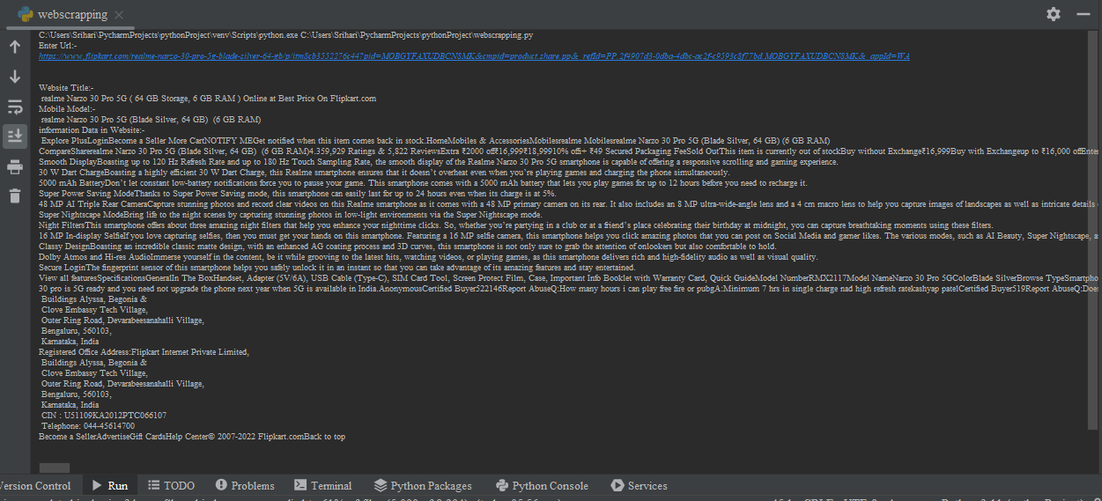

**6. RESULTS:-**

Finally I Done to Collect Successfully The Useful Information about The Realme Mobile Phone Details From The Flipkart E-Commerce Website Web Scraping Process.